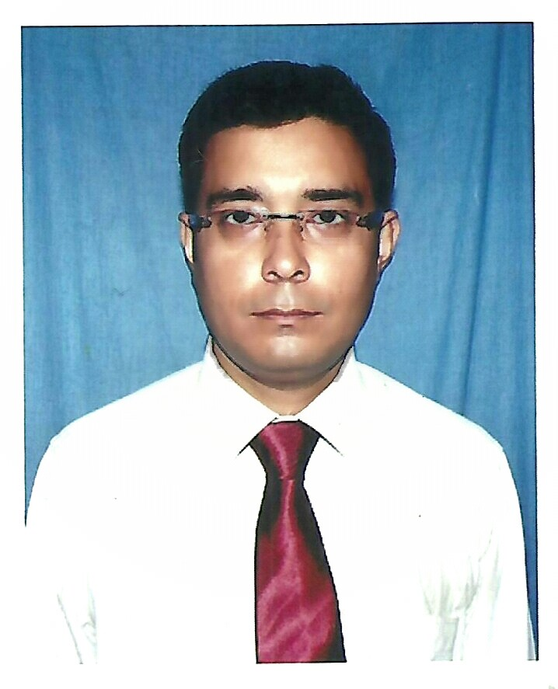
RUDRA PROSAD MUKHERJEE
Contact No: - 9475672009
Email id: - rudraprosad.mukherjee@gmail.com

Objectives(s)

To work in a challenging and highly competitive business environment and thereby explore and enhance personal abilities in order to uniquely contribute to the relevant business sector.

Educational qualifications

 Passed Bachelor of Library Information Science from Karnataka State University in 2012.
 Passed Bachelor of Commerce from University of Burdwan in 2007.
 Passed the Higher Secondary Examination (12th standard) from West Bengal Council of Higher Secondary Education in 2004.
 Passed the Secondary Examination (10th standard) from West Bengal Board of Secondary Education in 2002.

Professional Experience(s)

1st June 2010 to Till Date  Designation :  Business Development Manager  Location : SURI  CTC : 3.90 Lakh | Company : Reliance life Insurance Co Ltd  Responsibility :  a) Recruitment of 3 Sales Manager & Advisor.  b) New business generation from existing & new customers  c) Promotion of Sales Manager  d) Training and development of Sales Manager as well as Advisor  e) Responsible for Branch Profit and Renewal Persistency.  g) Produce Club Member  Achievement:  a) 2 Sales Manager Promotion  b) 3 Club Member Advisor  c) 2 Advisor Qualified Foreign Trip
1st October 2009 to 31st May 2010  Designation :  Executive Sales Manager  Location : BOLPUR  CTC : 3.24 Lakh | Company : Reliance life Insurance Co Ltd  Responsibility :  a) Recruitment of Advisor.  b) New business generation from existing & new customers  c) Produce Club Member  d) Training and development of Advisor  e) Responsible for Renewal Persistency.  Achievement:  a) Promotion from ESM to BDM  b) 3 Club Member Advisor  c) 1 Advisor Qualified Foreign Trip
1st April 2009 to 31st September  2009  Designation :  Sr. Sales Manager  Location : BOLPUR  CTC : 2.88 Lakh | Company : Reliance life Insurance Co Ltd  Responsibility :  a) Recruitment of Advisor.  b) New business generation from existing & new customers  c) Produce Club Member  d) Training and development of Advisor  e) Responsible for Renewal Persistency.  Achievement:  a) Promotion from SSM to ESM  b) 2 Club Member Advisor
20th August 2007 to 31st March 2009  Designation :  Executive Sales Manager  Location : BOLPUR, BASIRHAT  CTC : 1.80 Lakh | Company : Reliance life Insurance Co Ltd  Responsibility :  a) Recruitment of Advisor.  b) New business generation from existing & new customers  c) Produce Club Member  d) Training and development of Advisor  e) Responsible for Renewal Persistency.  Achievement:  a) Promotion from SM to SSM  b) 3 Club Member Advisor

Other Details

- Date of Birth | : | March 04. 1987
- Father’s name | : | Mr. Samarendra Mukherjee
- Permanent Address | : | Kirnahar  District – Birbhum,  West Bengal, India.  Phone No. :(0) 9475672009
- Nationality | : | Indian

- Few Subject Interest : Insurance and risk management, Insurance industries
IRDA guidelines, Strategic Management, Life and General Insurance, Group Insurance, Underwriting, claims settlement management accounting financial management marketing of service global market etc.

- Avocation : Making Friends, Traveling, like to play cricket, Football.

- Summary : Strongly focused on understanding objective and goals in developing and implementing effective insurance marketing strategies to achieve the set target

Reference: Available on Request.

Date: _______________ ______________________________
Signature

